

**End Semester Project**

**Impact of ChatGPT on Students’ Learning: Comprehensive Survey Report**

|  |  |
| --- | --- |
| **Submitted by** | Hamza Haroon, Noman Masood Khan |
| **Reg ID** | 211064, 211042 |
| **Class** | BS CYS VII-A |
| **Submitted To** | Ms. Asma Qasim |
| **Subject** | Technical and Business Writing |

**Executive Summary**

This report explores how ChatGPT impacts students' learning processes, academic performance, and critical thinking skills. The survey, conducted with 42 participants from high school and undergraduate levels, analyzes usage patterns, benefits, limitations, and ethical considerations.

**Key Findings**

* **Usage Patterns**: 80% use ChatGPT daily, primarily for assignments, concept clarification, and exam preparation.
* **Impact on Academic Performance**: 60% reported improved grades or understanding, while 10% noted dependency concerns.
* **Ethical Concerns**: While 80% believe using ChatGPT aligns with academic ethics, 50% raised concerns about reduced critical thinking skills due to over-reliance.

**Recommendations**

1. Promote responsible usage of ChatGPT through integration into learning curricula.
2. Educators should balance AI tools with traditional learning to foster critical thinking.
3. Developers should enhance ChatGPT's accuracy and features promoting active engagement.

**Introduction**

**Purpose Statement**

The purpose of this survey is to assess ChatGPT's influence on students' learning experiences, academic outcomes, and ethical considerations. The findings aim to help students, educators, and developers optimize ChatGPT's potential in educational contexts.

**Target Population**

The survey targeted high school and undergraduate students in Islamabad, primarily from cybersecurity, medical, and AI-related disciplines.

**Objectives**

1. Evaluate how ChatGPT assists in academic tasks such as assignments and exam preparation.
2. Identify its strengths, limitations, and impact on critical thinking.
3. Examine ethical concerns surrounding AI-assisted learning.

**Methodology**

**Pre-Survey Activities**

1. **Survey Development**: Questions were designed to be clear, unambiguous, and bias-free. Multiple-choice, Likert scale, and open-ended formats were used to capture comprehensive results.
2. **Pilot Testing**: Conducted with 20 volunteers to validate clarity and relevance. Feedback was incorporated to improve ambiguous items.
3. **Survey Introduction**: A professional and respectful tone was used in introductory communications, emphasizing confidentiality, benefits, and time commitment (10 minutes).

**Distribution Process**

1. **Platform**: Google Forms.
2. **Sharing**: Distributed via email and social media to ensure wide reach.
3. **Follow-Ups**: Two reminders sent to participants to maximize response rates.

**Response Rate**

* **Total Responses**: 42.
* **Response Rate**: 90%, categorized as **excellent** based on guidelines.

**Data Validation**

1. **Sampling Error**: ±5% at a 95% confidence level ensures statistical reliability.
2. **Significance Levels**: All results were validated at a 0.05 significance level.

**Survey Questions and Results Analysis**

Below are the **questions used**, their purpose, and the detailed analysis of responses.

**Demographics**

***Question 1: What is your age?***

* **Purpose**: To understand the age distribution of participants.
* **Findings**:
  + Majority (85%) were between 18–22 years.
  + Youngest: 16 years; Oldest: 24 years.

***Question 2: What is your current education level?***

* **Purpose**: To identify educational stages (high school vs. undergraduate).
* **Findings**:
  + 80% were undergraduates; 20% were high school students.

***Question 3: What is your field of study?***

* **Purpose**: To determine the diversity of academic disciplines.
* **Findings**:
  + Predominantly cybersecurity (75%).
  + Others included medical, AI, and military arts.

**ChatGPT Usage Patterns**

***Question 4: Which city are you currently studying in?***

* **Purpose**: To ensure the geographical relevance of data.
* **Findings**:
  + Most respondents were based in Islamabad, with a few from Rawalpindi.

***Question 5: How often do you use ChatGPT for educational purposes?***

* **Purpose**: To gauge usage frequency.
* **Findings**:
  + 80% used ChatGPT daily, 10% occasionally, and 10% weekly/rarely.

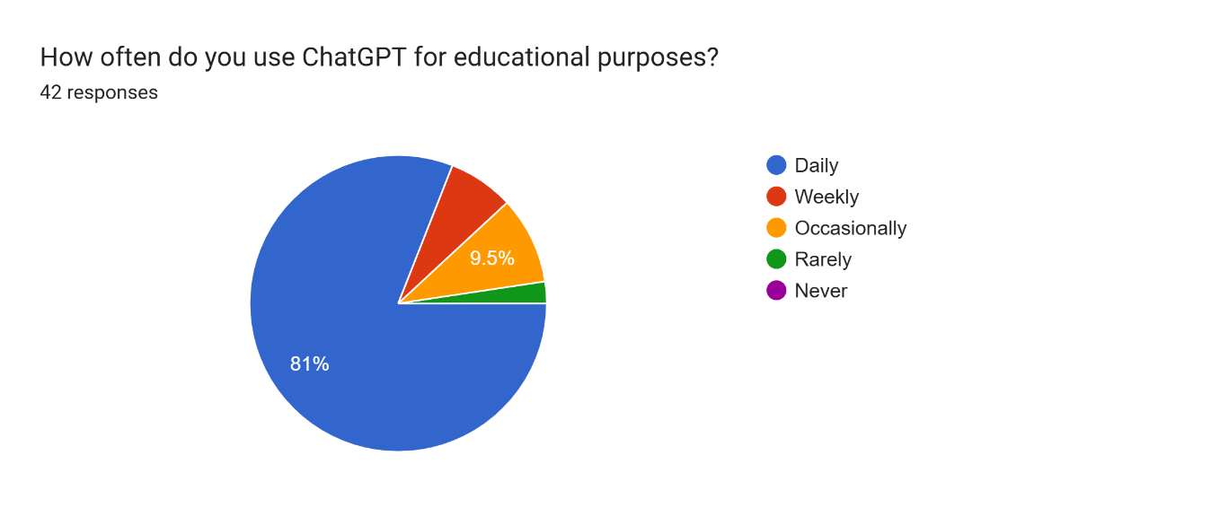

***Question 6: For what purpose(s) do you use ChatGPT?***

* **Purpose**: To identify the primary academic use cases of ChatGPT.
* **Findings**:
  + 85% used it for completing assignments.
  + 80% for clarifying concepts, 70% for preparing for exams, and 50% for generating project ideas.

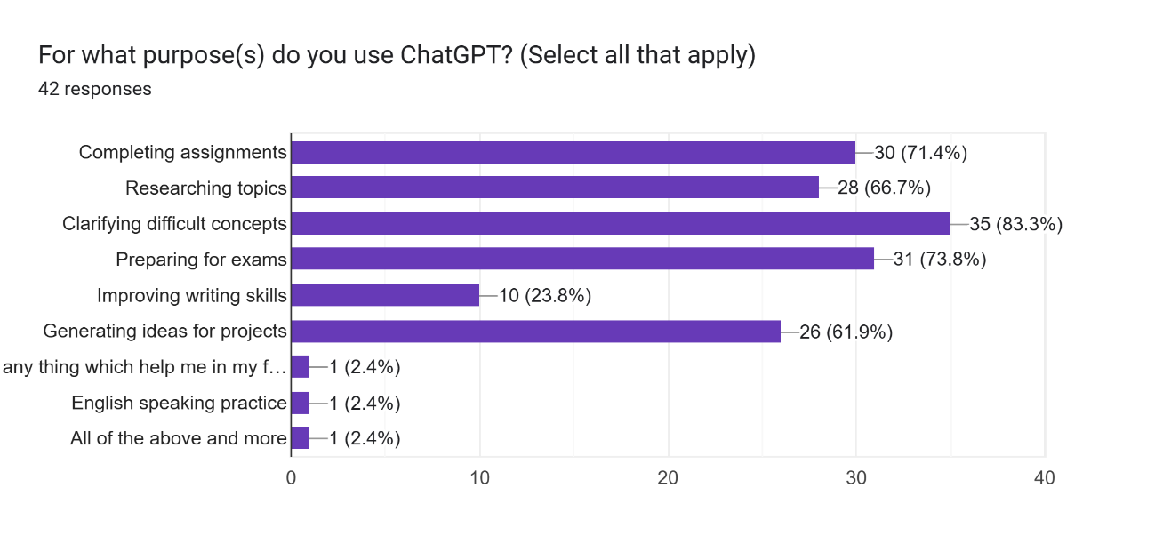

**Helpfulness and Academic Impact**

***Question 7: On a scale of 1 to 5, how helpful do you find ChatGPT for educational purposes?***

* **Purpose**: To measure overall satisfaction.
* **Findings**:
  + 85% rated it as "4" or "5," indicating high satisfaction.

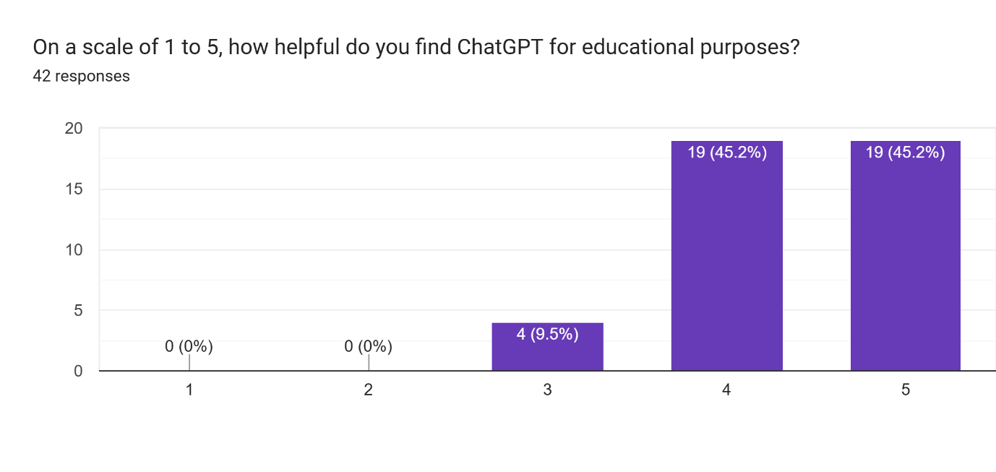

***Question 8: How long have you been using ChatGPT?***

* **Purpose**: To assess familiarity with the tool.
* **Findings**:
  + 70% had used it for over six months.

Forms response chart. Question title: How long have you been using ChatGPT?
. Number of responses: 42 responses.

***Question 9: Has ChatGPT helped you better understand academic concepts?***

* **Purpose**: To evaluate its effectiveness in improving understanding.
* **Findings**:
  + 78% agreed ChatGPT improved their understanding of academic material.

Forms response chart. Question title: Has ChatGPT helped you better understand academic concepts?
. Number of responses: 42 responses.

***Question 10: How has ChatGPT affected your academic performance?***

* **Purpose**: To determine its direct impact on grades.
* **Findings**:
  + 60% reported positive impacts (improved grades/understanding).
  + 10% noted negative effects, citing dependency concerns.

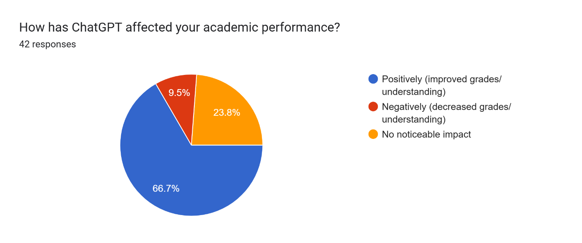

**Ethics and Critical Thinking**

***Question 11: Do you think ChatGPT aligns with ethical academic practices?***

* **Purpose**: To explore ethical considerations.
* **Findings**:
  + 80% believed using ChatGPT aligns with ethical practices.

Forms response chart. Question title: Do you think using ChatGPT aligns with ethical academic practices?
. Number of responses: 42 responses.

***Question 12: Do you think ChatGPT affects your ability to think critically or solve problems independently?***

* **Purpose**: To assess its influence on critical thinking.
* **Findings**:
  + 50% expressed concerns about reduced creativity and problem-solving.
  + 40% reported no significant changes.

Forms response chart. Question title: Do you think ChatGPT affects your ability to think critically or solve problems independently?
. Number of responses: 42 responses.

**Open-Ended Responses**

***Question 13: What is the biggest limitation of ChatGPT in supporting your learning?***

* **Results**:
  + Accuracy issues in technical subjects like math.
  + Over-reliance reduces critical thinking.
  + Difficulty with nuanced prompts.

***Question 14: What do you like most about using ChatGPT for learning?***

* **Results**:
  + Fast and efficient.
  + Simplifies complex topics.
  + Acts as a personal tutor.

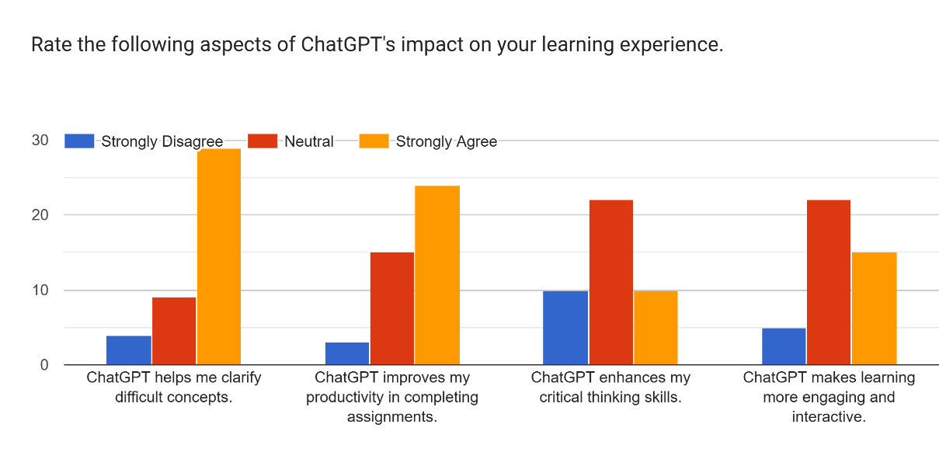

**Analysis of Open-Ended Responses**

***1. In your opinion, what is the biggest limitation of ChatGPT in supporting your learning?***

Participants identified various limitations of ChatGPT, categorized into the following themes:

**a. Accuracy Issues**

* Several respondents mentioned that ChatGPT occasionally provides **false resources** or **incorrect answers**, especially in **technical domains like mathematics**.
  + Example: *"Sometimes, ChatGPT gets the concepts wrong, especially in mathematics."*
  + Example: *"One of the main issues of ChatGPT is its factual accuracy."*

**b. Over-Reliance and Reduced Critical Thinking**

* A recurring concern was that students might become overly dependent on ChatGPT, affecting their ability to think critically and solve problems independently.
  + Example: *"It limits critical thinking and makes us dependent on it for everything."*
  + Example: *"ChatGPT only gives knowledge, not learning."*

**c. Lack of Personalization**

* ChatGPT’s inability to dynamically adapt to individual learning styles or provide hands-on interaction was cited as a limitation.
  + Example: *"It relies on pre-existing data and lacks personalization compared to a human tutor."*
  + Example: *"The biggest limitation is its inability to provide hands-on learning or experiential knowledge."*

**d. Miscellaneous Limitations**

* Some respondents mentioned additional issues, such as:
  + *“Too lengthy answers.”*
  + *“ChatGPT sometimes repeats or transmits inaccurate information.”*
  + *“Premium features are needed for better responses.”*

***2. What do you like most about using ChatGPT for learning?***

Participants appreciated several aspects of ChatGPT, grouped into the following categories:

**a. Speed and Efficiency**

* Many respondents valued ChatGPT for its ability to provide **fast answers** and make learning tasks more efficient.
  + Example: *“It’s convenient and saves time. I can finish assignments in minutes.”*
  + Example: *“Quick and to-the-point answers.”*

**b. Simplification of Complex Concepts**

* ChatGPT’s ability to break down difficult topics into simpler explanations was highly praised.
  + Example: *“It simplifies complex topics and helps me understand concepts easily.”*
  + Example: *“It can explain at whatever level of easiness I need.”*

**c. Accessibility and Availability**

* The availability of ChatGPT as a **24/7 virtual tutor** was noted as a significant advantage.
  + Example: *“It’s always available to assist with personalized tutoring and practice.”*
  + Example: *“It’s like having a knowledgeable companion always ready to explain.”*

**d. Versatility**

* Respondents highlighted the versatility of ChatGPT in supporting various tasks, such as coding, summarizing, and generating ideas.
  + Example: *“I can generate ideas for projects and overcome writer’s block.”*
  + Example: *“It helps with coding and troubleshooting efficiently.”*

**3. Additional Comments and Suggestions**

This section reflects feedback on how ChatGPT can be improved and integrated into learning environments:

**a. Suggestions for Improvement**

* **Accuracy and Customization**:
  + *“Sometimes GPT makes errors in mathematical equations. It should be improved in technical areas.”*
  + *“A better prompt system or interactive feedback loop could improve its responses.”*
* **Feature Enhancements**:
  + *“There should be no limit for uploading pictures.”*
  + *“Adding voice chat would make it more user-friendly.”*

**b. Reflections on Usage and Dependency**

* **Critical Thinking Concerns**:
  + *“Using ChatGPT too much reduces our ability to think critically and solve problems independently.”*
  + *“I’ve reduced my use of ChatGPT and now rely on it only for academic purposes.”*
* **Positive Reflections**:
  + *“ChatGPT has transformed my learning experience. It’s efficient and helps me focus on understanding rather than searching.”*
  + *“It should be included in academic curricula for its ability to simplify learning.”*

**c. Recommendations for Responsible Usage**

* *“We should use ChatGPT for learning but not rely on it entirely. It’s important to engage actively with the content it provides.”*
* *“Educators should guide us on using ChatGPT responsibly to enhance our skills without losing creativity.”*

**Comparative Analysis of Responses**

The survey responses revealed distinct patterns when analyzed across different demographic groups:

* **Education Level**:
  + High school students primarily used ChatGPT for exam preparation and clarifying concepts, while undergraduates relied on it for assignments, project ideas, and coding tasks.
* **Field of Study**:
  + Cybersecurity students focused on ChatGPT for coding, troubleshooting, and researching technical topics.
  + Medical and AI-related students emphasized concept explanations and project idea generation.
* **Usage Duration**:
  + Participants who used ChatGPT for over six months rated it more favorably in terms of helpfulness and reliability (average rating: 4.5) compared to those with less experience (average rating: 3.8).

**Ethical Considerations in AI-Assisted Learning**

**Key Ethical Issues**

The survey identified several ethical concerns related to ChatGPT usage in academic settings:

1. **Academic Integrity**:  
   While 80% of respondents believe ChatGPT aligns with ethical practices, concerns about misuse, such as plagiarism or over-reliance, remain significant.
   * *Example: “It’s important to use ChatGPT responsibly and not as a shortcut for actual learning.”*
2. **Critical Thinking and Problem-Solving**:  
   Half of the respondents expressed concerns about reduced creativity and independent problem-solving. Over-reliance on AI-generated solutions could hinder intellectual growth.
   * *Example: “Using ChatGPT too much reduces critical thinking and makes us dependent on it.”*
3. **Transparency and Accuracy**:  
   Some participants highlighted issues with inaccurate or incomplete information, emphasizing the need for students to verify outputs.
   * *Example: “ChatGPT sometimes gets concepts wrong, especially in technical areas like math.”*

**Recommendations for Ethical Usage**

* Educators should provide clear guidelines on using ChatGPT for learning tasks without compromising integrity.
* Developers should enhance transparency by including explanations or sources for AI-generated answers.

**Implications for Stakeholders**

The findings have significant implications for students, educators, and developers:

**For Students:**

* Use ChatGPT to supplement traditional learning resources, not replace them.
* Actively engage with the content provided by ChatGPT, verifying its accuracy and exploring alternative explanations.

**For Educators:**

* Integrate ChatGPT into the curriculum to teach responsible AI usage.
* Design assignments that encourage critical evaluation of AI-generated outputs rather than simple acceptance.

**For Developers:**

* Focus on enhancing ChatGPT's features to foster active learning, such as interactive tutorials or guided questioning.
* Improve accuracy in niche or technical areas like mathematics and coding to increase reliability.

**Limitations of the Survey**

While the survey provided valuable results, certain limitations should be noted:

1. **Geographic Scope**:
   * The majority of participants were from Islamabad and Rawalpindi, limiting the applicability of findings to a broader population.
2. **Sample Diversity**:
   * Cybersecurity students constituted 75% of the sample, which may overemphasize their specific academic needs and perspectives.
3. **Response Bias**:
   * Participants may have provided socially desirable answers, particularly regarding ethical concerns or dependency.
4. **Limited Qualitative Depth**:
   * While open-ended responses offered results, in-depth interviews could have captured more nuanced opinions.

**Addressing Limitations in Future Research:**

* Expand the survey to include participants from diverse geographic and academic backgrounds.
* Complement quantitative data with qualitative interviews to gain richer results.

**Future Research Directions**

This study provides a foundation for exploring ChatGPT's role in education. Future research should focus on:

1. **Global Perspectives**:
   * How does ChatGPT usage differ across regions, cultures, and educational systems?
2. **Long-Term Impacts**:
   * Assess the effects of prolonged ChatGPT usage on academic performance, creativity, and critical thinking over several years.
3. **Interactive AI Features**:
   * Explore how interactive or adaptive AI features, such as voice responses or dynamic feedback, could enhance learning outcomes.
4. **Integration into Curricula**:
   * Investigate best practices for incorporating ChatGPT into formal education while maintaining ethical and academic standards.

**Concluding Thoughts**

ChatGPT has emerged as a transformative tool in education, providing students with fast, efficient, and accessible assistance. However, its over-reliance can lead to reduced critical thinking and potential ethical concerns.  
Moving forward, a balanced approach is necessary:

* Students should use ChatGPT as a supplement, not a replacement, for traditional learning methods.
* Educators and developers must collaborate to foster responsible usage and design features that encourage active engagement and independent thinking.

By addressing its limitations and leveraging its strengths, ChatGPT can play a pivotal role in shaping the future of education.

**Appendix**

**Appendix A: Survey Form**

The survey questions used for this study are accessible via the following link:

<https://forms.gle/eFSNmrpvh3uJwc5c7>

**Appendix B: Survey Results**

The full dataset of responses collected during the survey can be accessed here:  
<https://docs.google.com/spreadsheets/d/13ln77u6lVL06BIMV0SWlvjxP9XvCX7VpGN9noi7wn0c/edit?usp=sharing>